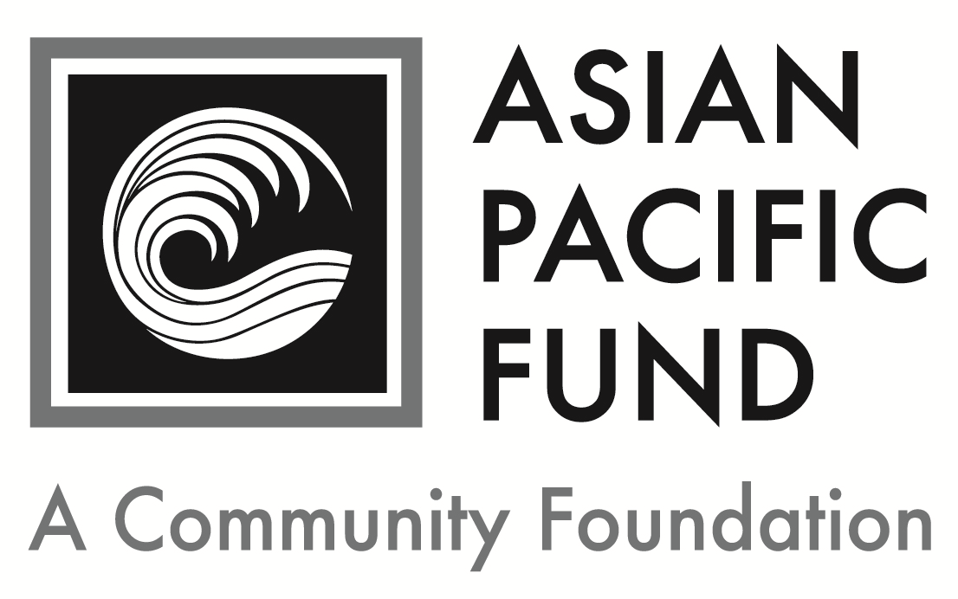
Banatao Family Filipino American Education Fund

Postmark Deadline: Friday, February 23, 2018
Eligibility Criteria:
- Grade level: Incoming freshman enrolled full-time at an accredited four year-college or university in 2018-19
- Career: engineering, computer, physical or environmental sciences (excluding healthcare professions)
- Ethnic heritage: Filipino heritage (at least 50%)
- Minimum GPA: 3.0
- Financial need
- Residency:
  - Northern California counties: Alameda, Contra Costa, Marin, Merced, Monterey, Napa, Sacramento, San Benito, San Francisco, San Joaquin, San Mateo, Santa Clara, Santa Cruz, Solano, Sonoma, Stanislaus or Yolo
  - Southern California counties: Los Angeles, Orange or San Diego

Background Information:
- Number of awards: 5
- Amount: $5,000 (annual award)
- Renewable? Yes
- Total award: $20,000

Selection Criteria:
- Academic achievement, especially in the sciences
- Well-informed educational and career goals in engineering/science
- Personal strengths, including maturity, motivation and potential to succeed
- Honors
- Work experience
- Financial need

Application Checklist: Applicants are responsible for submitting all materials to the Asian Pacific Fund by the deadline. Incomplete applications will not be evaluated. This application becomes complete and valid only when the Asian Pacific Fund has received all of the following materials:

Completed student application form
Essays
Most recent transcript(s) of grades (including grading scale); unofficial transcripts are OK
Resume (include work experience, school activities, community service, honors & awards)
Two letters of recommendation, at least one of which is from a current teacher
Letters should be on official school or organization letterhead. Please include the student’s first and last name.

Note: 15 to 25 finalists will be chosen. Finalists must be available for a 30-minute interview in mid-April 2018 in San Francisco for Northern California candidates, or in one of the three qualified counties for Southern California candidates (exact dates TBD). If chosen for interview, finalists must submit official transcript(s) of grades, SAT/ACT score reports and FAFSA student aid report. Applicants will be notified before May 1 whether or not they have been selected as scholarship recipients.

Completed application form with supplemental materials must be postmarked by Friday, February 23, 2018. Please send to:

Banatao Family Filipino American Education Fund
Asian Pacific Fund
465 California Street, Suite 809
San Francisco, CA 94104

Questions? Check our Frequently Asked Questions page or e-mail scholarship@asianpacificfund.org.
Scholarship Application

To apply, please complete the following application form. Please type or print legibly.

Contact and Household Information
Personal Information
First name: |  |  | Middle name/initial: |  | Last name:
Home phone:  ( ) - |  | Cell phone:  ( ) - |  |  |  |  | Date of birth: / /
Email address: |  |  |  | Gender:  Female Male
Ethnic Heritage of… (not names)
Mother: | Maternal Grandmother: |  |  |  |  | Maternal Grandfather:
Father: | Paternal Grandmother: |  |  |  |  | Paternal Grandfather:

Permanent Residence
Address (Number & Street): |  |  |  | Apartment/Suite:
City: | State: | Zip Code: | County (not Country):

Mailing Address (if different from above)
Address (Number & Street): |  |  | Apartment/Suite:
City: | State: | Zip/Postal Code:

Parent or Guardian Information
First name: |  | Middle name/initial: |  | Last name:
Relation to applicant: | Telephone:  ( ) - |  | Email address:
Address (if different from above):

Will you be the first in your immediate family (parents and siblings) to attend and graduate from college? Yes No

Publicity
How did you hear about this program? (please check all that apply)
College/Career Counselor Teacher Family/Family Friend
Internet (please specify): Other (please specify):
First & last name:
Financial Information

Parents’ Financial Data (to be completed if student is still in parents’ household or claimed as a dependent. Use data based on most recently filed tax form or “Your Parents’ Information” on most recent FAFSA form)
Adjusted Gross Income:  (Form 1040 – line 37) |  |  | Total Cash, Checking, Savings & Cash Value of Stocks:  (exclude retirement plan funds, IRA, 401K)
Total Income of Father: |  |  |  |  | Occupation of Father:
Total Income of Mother: |  |  |  |  | Occupation of Mother:
Marital Status of Parent(s)/Guardian(s): |  | Married Divorced Separated  Widowed Single
Amount of additional income: |  |  |  | Source(s): |  | Child Support Social Security  TANF Other:
Special Financial Circumstances:

Student’s Financial Data (to be completed if the student is employed part- or full-time)
Adjusted Gross Income:  (Form 1030 – line 37) |  |  | Total Cash, Checking, Savings & Cash Value of Stocks:  (exclude retirement plan funds, IRA, 401K)
Total Income: |  | Occupation: |  | Average hours worked per week:

Household Information: Some programs have a maximum household income requirement. Please see eligibility criteria for maximum household income to be considered for the scholarship.
Annual Household Income (please check one):
< $20,000 $20,000 - 39,999 $40,000 - 59,999
$60,000 - 79,999 $80,000 - 99,999 $100,000+ (actual: )
Please provide your Estimated Family Contribution (EFC):
The EFC is located on the top-right of page 1 of the FAFSA Student Aid Report. If you are ineligible to apply for FAFSA, write "Not Applicable" in this field. If you have not completed your FAFSA, use the FAFSA4Caster to estimate your EFC.
Number of people in household supported by reported income:
Number of household members attending college in 2018-19:

Other Awards: List the name and annual amount of any grants/scholarships you have been awarded for 2018-19.
Name of Award: | School to which award will be applied: | Amount: | Status:
 |  | $ | Granted Pending
 |  | $ | Granted Pending
 |  | $ | Granted Pending

First & last name:
Academic and Career Information

Academic Information
High School: |  |  | City:
Weighted GPA: |  | Unweighted GPA (4.0 scale):
Expected High School Graduation Date: Month / Year

Test Scores: Please write “N/A” if you have not taken the tests below.
SAT Math: |  | SAT Reading & Writing: |  |  | SAT Essay:
SAT Subject Tests  (if taken): | Subject: |  | Score: | Subject: |  | Score:
 | Subject: |  | Score: | Subject: |  | Score:
ACT
Composite: English: Mathematics: Reading: Science:

College/University Information
Status of College Decisions:
 | School | City, State | Acceptance Status
 |  |  | Accepted | On waitlist |  | Awaiting reply
1st Choice
2nd Choice
3rd Choice

Other College Information:
Intended major: | Expected College Graduation Date:  Month / Year
Housing plans for 2018-19: Commute from home Live on campus Live off campus
If attending a public college/university, will you be paying in-state tuition? Yes No

Essay Questions
Please respond to each of the short essay questions below on a separate sheet of paper. Your essays should be in 12-point font and single-spaced. At the top of the page, include your name and the name of the scholarship program. After each essay, please include the word count.
- Tell us about yourself, including your academic and career goals, hopes and dreams for the future and the role/influence of your Filipino heritage. Recommended length: 250-500 words
- Describe your proudest moment and the greatest challenge you have faced, either personally or academically. What did you learn from these experiences? Recommended length: 150-200 words
- What area of engineering, math or science most interests you and why? How did you develop this interest? Recommended length: 250-500 words
- Describe a project, experience or person related to your academic and/or career goals that inspired you. What impact did it have on you? Recommended length: 150-200 words
- Optional: Is there anything else you would like us to know, including any unusual family or personal circumstances that have affected your achievement in school, work experience or your participation in school activities?
Complete & sign portion below:
I state that all of the information provided in this application is true, and, if selected as a recipient of the Banatao Filipino American Education Fund College Scholarship, I agree to provide additional documentation that is required.

I also acknowledge that Dado and Maria Banatao are the Benefactors of the Banatao Filipino American Education Fund. I affirm under penalty of perjury that I, (print student name) , am not related to the Benefactors in any of the following ways: household member, family member (brother, sister, uncle, aunt, grandparent, or first cousin, or any of the listed relationships by marriage), and descendant (child or grand-child whether or not they are household members).

Furthermore, I affirm under penalty of perjury that no one in my family or household, including myself, is an employee of the Benefactors or, to the best of my knowledge, an employee of a company in which the Benefactors hold controlling interest.

Student Signature: _______________________________ Date: _________
Print Student’s Name: ________________________

If student is under 18 years old:
Parent’s Signature: ________________________________ Date: _________
Print Parent’s Name: __________________________

