UC
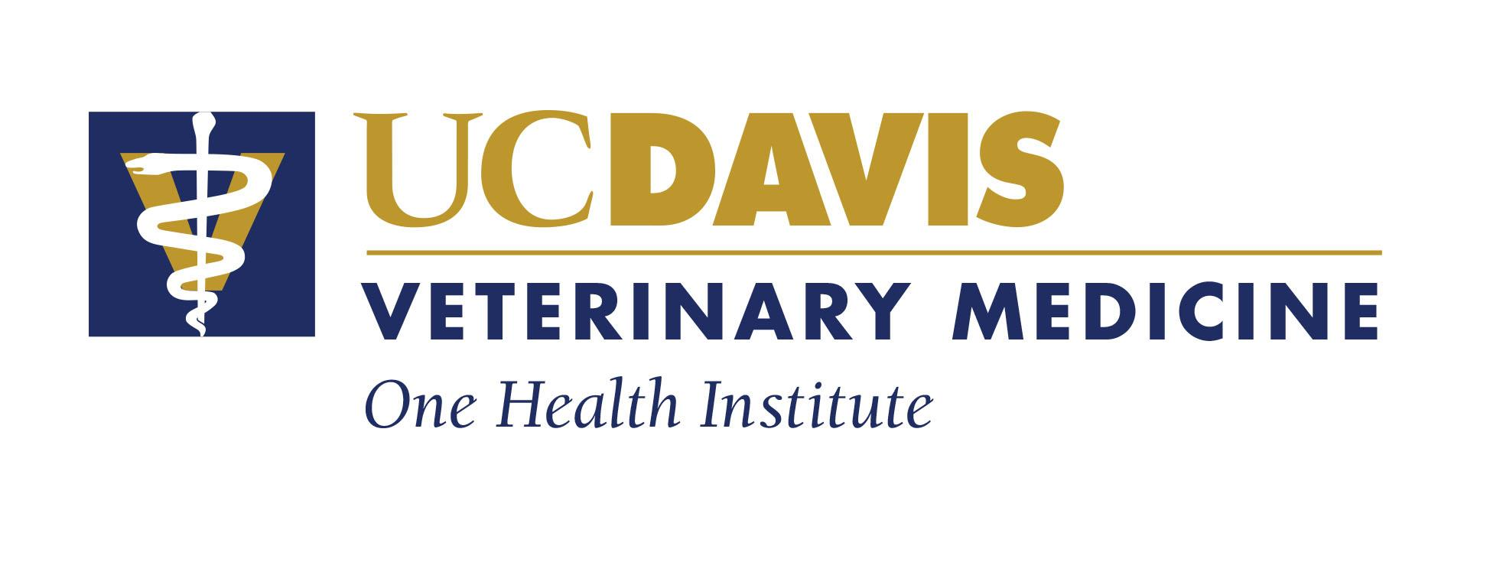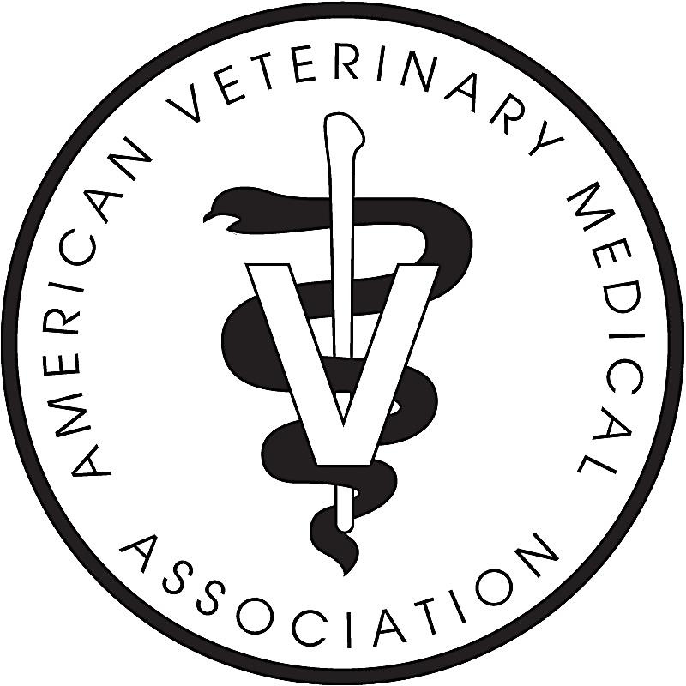

Do you have an interest in Veterinary Medicine?  The UC Davis Veterinary Medicine Exploration Academy is designed to provide 9th, 10th, 11th and 12th grade students with an interest in animal science the opportunity to get a first-hand look at the variety of fields of study that make up veterinary medical education. This 3-Saturday enrichment program will take place September 28th, October 5th, and October 12th. It will provide a unique look into the world of animal science. The program will challenge students to engage and learn about the field as participants in laboratory practical analysis, anatomy review, pathology, radiology and a variety of lectures presented by the UC Davis School Veterinary Medicines’ faculty, veterinary students and staff.  Students who are selected as participants will be REQUIRED to participate in all three Saturday dates of the program (NO EXCEPTIONS). In addition, prior to the start of the program participants are REQUIRED to attend the program orientation at UC Davis with their parent/guardian on Wednesday,  September 25th, 2019 at 6-7 PM.  Admission to this program will be competitive. In order to qualify for participation you must meet the following criteria:  - Must be in good academic standing at your local high school with a GPA of 2.8 or higher  - Must have an interest and a record of academic success in high school math/science courses.  Additional Documentation REQUIRED:  - Provide a copy of your most recent high school transcript (unofficial copy is OK – report cards will not be accepted)  - Complete the application and answer the two essay questions (*REQUIRED)  Please MAIL or FAX your application to:  (Friday September 13th by 5 pm)  UC Davis, Early Academic Outreach Program (EAOP)  2210 Haring Hall  One Shields Avenue  University of California, Davis  Davis, CA 95616  Fax# (530) 752-9326 | PROGRAM APPLICATION Due: Friday September 13thby 5pm  Student Information  Name:__________________________________________  High School: _____________________________________  Home Address: ___________________________________  City _____________________ State ____ Zip __________  Home Phone: ____________________________________  Cell : _________________________________________  Email: __________________________________________  Can you attend a Student/Parent Program Orientation on Wednesday 09/25/19 at 6:00-7:00 PM in Davis?  (circle one) Yes No  Highest level in school completed by your parents:  Father: (Circle one) High School 2 Yr. College 4 Yr. College Mother: (Circle one) High School 2 Yr. College 4 Yr. College  ______________________________________  Essay Questions  Please address the following two questions in 350 words or less (use the back of this page or attach additional pages as needed):  1) Describe yourself, your educational and career goals.  2) Why are you interested in veterinary medicine?  For questions please call Harold Stewart-Carballo at the UC Davis EAOP Office at (530) 754-5017 or through email at hjstewart@ucdavis.edu.  This program is provided free of charge and ONLY available to UC Davis EAOP students.

UC Davis Veterinary Medicine Exploration Academy Fall 2019
Three Saturdays: September 28th, October 5th, and October 12th

